**CNN on BU-2018-project**

Kaggle name : RuiChen

I implement a CNN for Text Classification in TensorFlow on Amazon dataset.

1. Preprocessing
2. Use a [Bag of Words model](https://en.wikipedia.org/wiki/Bag-of-words_model)
3. Change label to one-hot vectors
4. Architecture of CNN

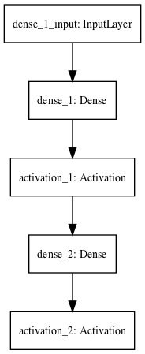

1. Result:

